Practical 6
Code: http://github.com/bhavyakumar18/DSA/tree/main/Practical%206
Problem 1
I faced difficulty in checking whether the stack was full or empty before performing push and pop operations. I solved it by keeping track of the top position. Before push, I checked if top == n-1, and before pop, I checked if top == -1. If the stack was full or empty, I displayed an error message instead of performing the operation.
Output:
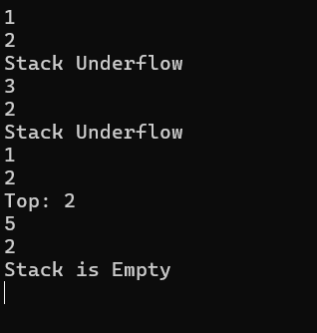
Problem 2
I faced difficulty in managing the page history because the size was not fixed. I solved it by using a dynamic stack that can grow when new pages are visited and shrink when the back operation is performed. When the user presses back on the first page and no history is left, I display a message that there is no previous page.
Output:
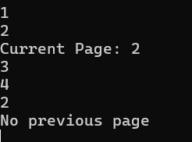

Problem 3
I faced difficulty in handling operators and brackets while converting an infix expression to postfix. I solved it by using a stack for operators. I checked the priority of operators and handled brackets properly so that operators were placed in the correct order after their operands.
Output:
